**Properties of continuous time Fourier Series**

**Lab Report# 11**

**Spring 2022**

**CSE301 - L**

**Signals & Systems Lab**

**Submitted by:**

**Hamid Ur Rehman**

**Registration:**

**20PWCSE1969**

**Class Section:**

**C**

**“On my honor, as student of Engineering and Technology, I have neither given nor received unauthorized assistance of this academic work”.**

**Submitted to:**

**Engr. Durr-e-Nayab**

**7/16/2022**

**Source Code:**

clc; clear; close all;

t = -1.5:0.005:1.5;

T = 1;

w0 = 2*pi/T;

M = 10;

x = zeros(1,length(t));

k = -M:M;

for k = -M:M

if abs(k)<3

x = x + 1j*k*exp(1j*k*w0*t);

else

x = x + 0*exp(1j*k*w0*t);

end

end

figure;

p=plot(-t,real(x),'lineWidth',2);

grid;

xlabel('t'); ylabel('x(t)') ;

title('x(-t)');

x1=-M:-2;

y1=0.*x1;

x2=-2:2;

y2=1j.*x2;

x3=2:M;

y3=0.*x3;

kk = [ x1 x2 x3 ];

ak = [ y1 y2 y3 ];

figure;

plot( -kk , imag(ak),'lineWidth',2);

grid;

xlabel('t'); ylabel('x(t)') ;

title('a(-k)');

xx = zeros(1,length(t));

for k = -M:M

if abs(k)<3

xx = xx + 1j*-k*exp(1j*k*w0*t);

else

xx = xx + 0*exp(1j*k*w0*t);

end

end

figure;

plot(t , real(xx),'lineWidth',2);

grid;

xlabel('t'); ylabel('x(t)') ;

title('a(-k)');

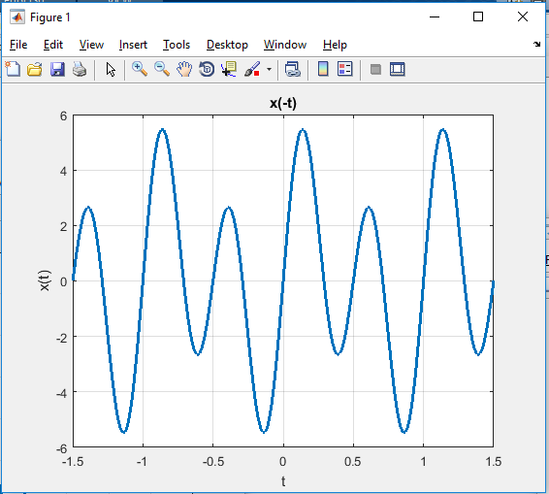**Output:**

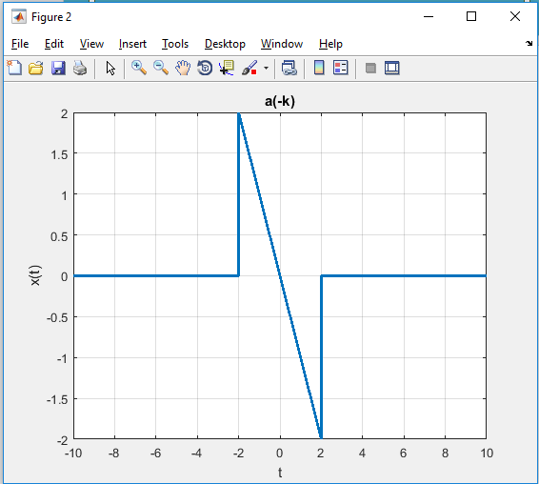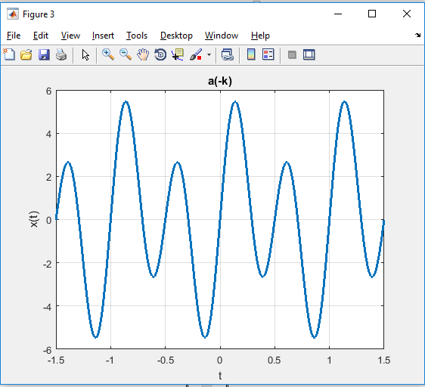

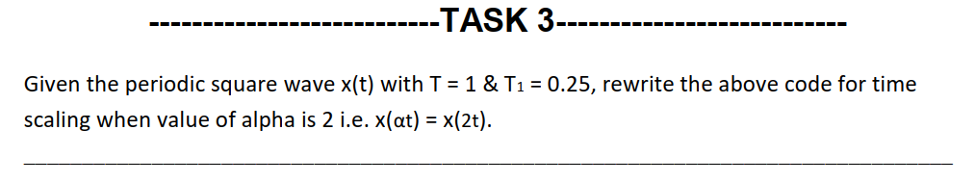**Source Code**

clc; clear; close all;

t = -1.5:0.005:1.5;

xcos = cos(2*pi*t);

xt = xcos>0;

k = -50:50;

T = 1;

T1 = 0.25;

ak = sin(k*2*pi*(T1/T))./(k*pi);

ak(51) = 2*T1/T;

alp1 = 2;

w0 = 2*pi/T;

w1 = alp1*w0;

xat1 = zeros(1,length(t));

for k = -50:50

xat1 = xat1 +ak(k+51)*exp(1j*k*w1*t);

end

figure(1);

subplot(2,1,1);

plot(t,xt,'lineWidth',2);

ylabel('x(t)');

title('Periodic Square Wave (T=1, T1=0.25)');

axis([-1.5 1.5 -0.2 1.2]);

grid;

subplot(2,1,2);

plot(t,real(xat1),'lineWidth',2);

ylabel('x(t)');

title('Reconstruction from ak''s (alp1=2, w1=2*w0)');

axis([-1.5 1.5 -0.2 1.2]); grid;

**Output**

